cURTIS STEVENS
PHILOSOPHY 1000
WILLIAM JAMES
A BRIFE REPORT ON HIS PHILOSOPHY
.
4/14/2012

William James
Philosopher, William James, was revolutionary in developing the pragmatism philosophy. He taught we should find beliefs and values that help us become better and happier people. These beliefs and values should move us forward to action. James found our most destructive behaviors are tied to boredom, negativity or being idle or passive.
The Life of William James
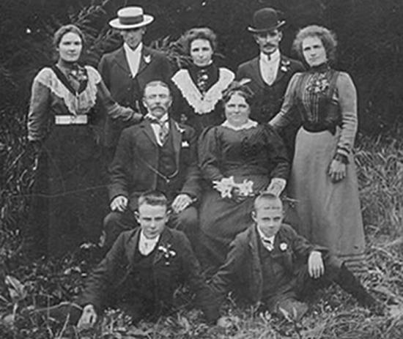
William James was born January 11, 1842. His father was Henry James Sir. He was born into a wealth family. His siblings include the writers Henry James and Alice James. The James family was encouraged to seek education. He and his family lived in Europe for a time. While there he attended a new school every year. He became fluent in German and French. He originally started his education in science. Later he tuned to art; he gained an apprenticeship with an artist in Newport. After a year and a half in art he changed his education direction back to science.
James Family. Photo courtesy of University at Albany
Through out his life, he experienced sickness, both physical and psychological. He was diagnosed with Neurasthenia. This condition came with anxiety, headaches, depression and fatigue. The sickness was thought at the time to be an exhaustion of the nervous system. There was a period in his life where, for months, he considered suicide.
In 1864 He started school at Harvard University. He studied medicine, biology and psychology. He received his MD in 1869. In 1873 he became an instructor at the school, teaching physiology. In 1876 He started to teach psychology.
In 1878 He married Alice Gibbens. His father had introduced them two years prior. In fact, his father had told him this would be the girl William would marry. William originally wrote letters to Alice to turn her away from him. Slowly, his letters turned to courtship. He gives her full credit for the man he became.
In 1885 he became a full professor at the university. He published his most recognized book, Principals of psychology in 1890. This book took him twelve years to write. He retired from the university in 1907. He died in 1910 due to heart failure.
During his life was he constantly writing. John McDurmott put together a bibliography of William James writings. The bibliography filled 47 pages.

Pragmatism
James was an original member of the Metaphysics club. This club had other philosophical members such as Charles Sandars Peirce, Chauncey Wright and John Dewy to name a few. It was working with these great minds that the term that “Pragmatism” was created. James gives credit to Peirce. Pragmatism is viewed in the dictionary as: 1. of or pertaining to a practical point of view or practical considerations.
2. Philosophy . of or pertaining to pragmatism ( def. 2 ) .
3. of or pertaining to pragmatics ( defs. 1, 2 ) .
William James and Charles Peirce. Image courtesy of The New Your Review of Books
4. treating historical phenomena with special reference to their causes, antecedent conditions, and results.
5. of or pertaining to the affairs of state or community (“Pragmatism” 1).

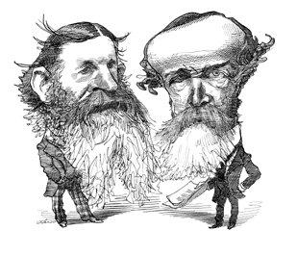
“Pragmatism from the Greek word for ‘deed’; belief that ideas have meaning or truth value to the extent that they produce practical results and effectively further our aims; empirically based philosophy that defines knowledge and truth in terms of practical consequences.” (Soccio 423)

Truth

James believes that “Truth” is something that has to be helpful, useful and practical. I feel that it is human nature for us only believe something is true after it is proven to be so. We need verification. According to James, a truth is only accepted after factual evidence gives verification to the truth. “Ideas are tested and accepted or rejected on how well they work for us.” (Soccio 435)

In the book Archetypes of wisdom, James is quoted, “Any idea upon which we can ride, so to speak; any idea that will carry us prosperously from any one part of our experience to any other part, linking things satisfactorily, working securely, simplifying, saving labor, is true for just so much, true in so far forth, true instrumentally” (435). If you have this idea or truth that you feel so strongly about, that you can make things better or carry this idea through to reach a positive conclusion, I share James’ belief, that it is a worthy action. We should be seeking such ideas.

An argument that exists between James and Rationalists is that, Rationalists believe that truth is universal. This is rejected by James stating that “truth happens to an idea.” According to James, in his book The Meaning of Truth, when faced with options, your mind is forced to choose a path. Our will to believe will determine our choice, not rationalism (James 875).

The technology of truth is referred to as know-how. I feel I know of many things, but the actual know-how of something that I don’t have or understand, I seek out help or advice from other individuals that do have the know-how. I feel know-how can be gained from past experiences that we learn for ourselves. Receiving and education and being taught is another way to gain know-how.

In another lecture by William James, regarding his view on truth, he stated, “Better a necessary lie than a destructive and unnecessary truth.” It should not be mistaken that James did believe in the truth. He did believe there where degrees of truth. Truth is always personal. We develop our perspectives by events in our lives. When communicating with one another, we do need to be aware of how we affect one another. James believes it is okay to sacrifice the truth, only when we my hurt someone by unimportant information.

Free Will

Determinism is defined as: “Belief that everything that happens must happen exactly the way it does because all matter is governed by cause and effect and follows laws of nature.” (Soccio 437) Cause and effect to me is a simple term. If this is what you do, this is your result. Is it true that if you do the same thing over and over and over again you will get the same result? According to the laws of nature you will. I believe there will always be an effect. It might not always be the same as the one before, but it will happen.

Moral philosophers believe that free will is something that individuals need to have to a sense of moral responsibility. James agrees with this philosophy. James’ religious perspectives where based on the idea of free will. For James, your free will allows you to choose your religion and to make life choices to the best of your ability. Your free will should be used to inspire you to make good choices and to try to make your self the best that you can be.

Morality

James viewed our moral enemy to be boredom. He listed the negative effects as: depression, alienation, drug use, suicide, weak work ethic and a lack of discipline. He suggested the remedy: participate in life passionately. To avoid boredom, we can volunteer in our community. He also indicates we need to have a hero, someone we want to be like. Their example should include good moral attributes.

There are two types of lives, one is to avoid risk, stress, and things that will take us from our comfort zone. The other is to live life seeking risk, danger and living courageously (Soccio440). Regardless of what life you are living, all of us should be passionate about some aspect of life.
Religion
James philosophy does encourage religion. He depicts this to be the essence of our social world. He believes we need religion to heal our sick souls. Healthy mindedness may come naturally to some but others will need the guidance of religion to help them. (“William James” 39)
To James, our religious belief should be moderate, educated and diverse. We should be respectful and tolerant of others religious choices. We should avoid Religion that seems fanatical, uneducated or intolerant. We should also avoid Religions that are cynical, disrespectful, rude or short-minded; as these will take away from positive moral values we should be striving for.
Are William James’ theories relevant today? Do they affect our society? Yes. We can see the influence of his philosophy. His moral is reflected as a basic social skill and the image of the perfect citizen in society. Through my research on William James, I find his theories make total sense to me. We should be seeking happiness and positive environments. We should also be an active participant in creating these environments.

Works cited
James, William. William James Writings 1902-1910. New York: The Library of America, 1987. Print.
“Pragmatism”. Dictionary.com. n.p., n.d. Web. 7 April. 2012
Soccio, Douglas F. Archetypes of Wisdom: An Introduction to Philosophy. Belmont: Wadsworth Cengage Learning, 2010. Prit
“William James”. Plato.Stanford.edu. Stanford encyclopedia of philosophy, September 7, 2000. Web. 7 April. 2012

